https://www.jdoodle.com/embed/v0/69Rs
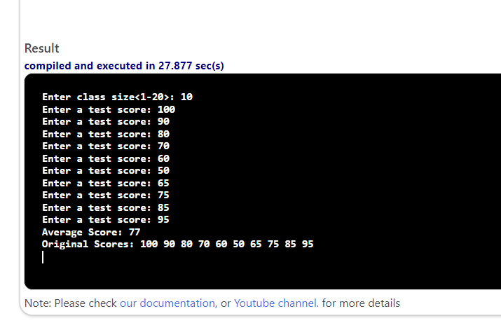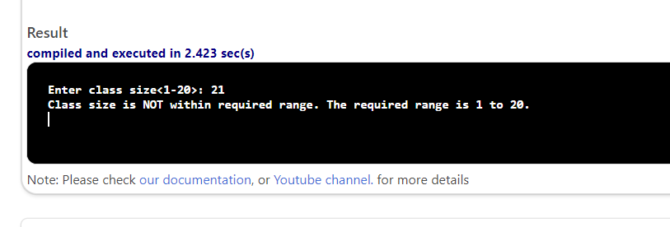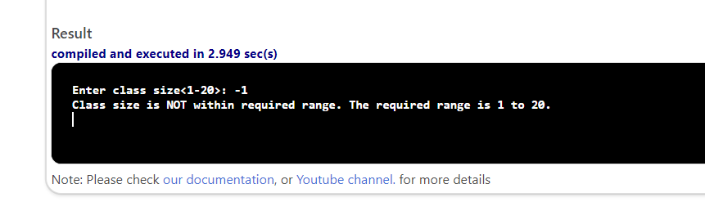

#include <iostream>
using namespace std;

int main() {
double scores[20];
int classSize, i;
double sum = 0.0, average;

cout << "Enter class size<1-20>: ";
cin >> classSize;

if (classSize < 1 || classSize > 20) {
cout << "Class size is NOT within required range. The required range is 1 to 20." << endl;
return 0;
}

for (i = 0; i < classSize; i++) {
cout << "Enter a test score: ";
cin >> scores[i];
sum += scores[i];
}

average = sum / classSize;

cout << "Average Score: " << average << endl;

cout << "Original Scores: ";
for (i = 0; i < classSize; i++) {
cout << scores[i] << " ";
}

cout << endl;
return 0;
}

